## horizontal line



Yeovil Healthcare Products

Website and Backend Systems

**─**

Lawrence Coles, Tommy Hamblin, and Joshua Youngman

**Table of Definitions/Acronyms** **2**

**Overview** **2**

**Iteration Overview** **3**

First Iteration 3

Customer Requirements 3

Second Iteration 4

Customer Requirements 4

Third Iteration 5

Customer Requirements 5

**First Iteration** **6**

Deliverables 6

Quality Criteria 6

Gantt Chart 7

**Work Log** **7**

**Bibliography** **9**

**Appendix** **10**

# 

# Table of Definitions/Acronyms

|  |  |
| --- | --- |
| **Acronym** | **Description** |
| Apache Tomcat | Tool used to deploy Java Servlets and JSPs |
| Eclipse | An Integrated Development Environment |
| SQL | Structured Query Language |
| Git | A version control system for tracking changes in computer files and coordinating work on those files among multiple people |
| JDK | Java Development Kit |
| XML | eXstensible Markup Language |

# Overview

This document contains a high-level plan of what can be achieved in the first three iterations of development for the Yeovil Healthcare Products package of work as described in the Systems 2 Assignment 2 assignment brief (Yeovil College, 2017).

This report contains a plan for the implementation of the first iteration, along with further deliverables for the project completion and a defined quality criteria. These will be used to plan the deliverables to be implemented at a future date.

# Iteration Overview

## First Iteration

This initial iteration will contain the configuration of the developmental web server and the associated developmental tools that we will need to implement the desired website. This will include:

* Apache Tomcat Server: Any 8.0.XX variant.
* Eclipse Java: From Mars
* MySQL Community Server: From 5.0.0
* Git: From 1.0.0
* Java JDK: From 1.7

Hardware Issues and Constraints

The customer will require a physical server and a web server to run host the website.

This iteration will also contain the design, implementation, testing and documentation of:

### Customer Requirements

The option to search through the current product range to be provided as three options:

* By keyword search
* By brand name
* By generic product name

This will result in a front-end display of the product warehouse with search functionality on the above key fields, similar to:

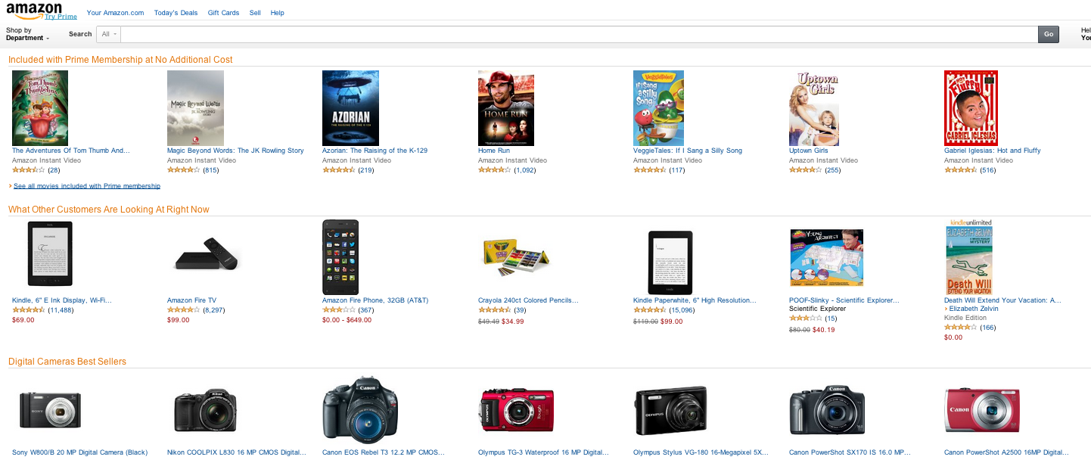

(Amazon, n.d.)

At this stage, there will need to be a database implementation to store the products. This will need to allow the adding of products. The client server infrastructure available to retrieve these values will also need to be implemented.

Products need to be loadable into the system at a folder level via XML files in any group of 1 or more.

The system will support 2000 products at this stage with the scope for further expansion.

## Second Iteration

This iteration will include functionality allowing users to create and log into customer accounts, as well as the use of a basket functionality to store multiple items when ordering more than one product at a time.

This iteration will contain the design, implementation, testing and documentation of:

### Customer Requirements

* Customers are required to register as account customers.
* Customers can order more than one of an item but how do I deal with order quantities which are in excess of what is in stock and available?

This will require the development of multiple tables: one for customer accounts, one for the basket, and another to store purchase histories in.

There will also need to be an admin account alongside the customer accounts that can modify and remove user accounts.

The system will support 10000 products at this stage.

## Third Iteration

The third iteration of the developmental cycle will include the full design, implementation, and testing of the following requirements. This will also include the documentation of each of these steps of the development.

This iteration will be concluded as fully completed once the end user can modify the delivery address of an order, and only provide the ability to deliver to UK customers. The requirements for the third iteration are:

### Customer Requirements

* A customer may be ordering for someone else, perhaps an elderly parent or relation or a present for a friend, or it could be a chain of retail outlets. The delivery address may be different to the customer’s address.
* I only want to sell to UK and Republic of Ireland customers

This iteration will require the website to provide the functionality to allow end users or customers to change the delivery address whilst ordering an item. Customers will be required to either select an existing address that is to be stored in their account details, or enter the details of a new delivery address, which will also be stored in the website back-end database for further future use. A default option for the delivery address will also be stored on the customer’s account details so that the delivery address automatically defaults to this address for speed and convenience. This functionality will, therefore, require the capability to store multiple delivery addresses per user in the database. This can be achieved by having an individual database table for the addresses and an input form in the website to provide the functionality to enter new delivery addresses.

To allow the website to only sell products to UK customers (requirement twelve), this will use a restrictive measure to prevent non-UK customers from being able to have products delivered. This will be achieved by implementing validation criteria into the delivery address entry fields of the website to restrict deliveries to only UK addresses for each specific order. Also, when a new user creates an account on the website, they will only be given the option to specify the United Kingdom as the customer’s address of residence, which will then default to the account’s delivery address. This will help to make the customers more aware that this is a UK-only website. It may also be necessary to include extra information throughout the website design and structure informing users that items and products can only be delivered to UK addresses.

The system will support 15000 products at this stage.

# First Iteration

## Deliverables

Successful completion of Iteration 1 will include the released web site hosted on a server.

It will deliver functionality such that a pre-populated backend database containing products may be displayed in a web page.

The products will be searchable by:

* By keyword search
* By brand name
* By generic product name

The system will be able to hold up to 2000 products.

## Quality Criteria

The quality criteria are the minimum requirements of the website product for it to be of adequate quality on completion of the project for the customer (The Law Dictionary, n.d.). This will provide quantifiable measures to assess the developmental progress of the website (Hastings, 2008).

Iteration one of the developmental phase includes the installation and configuration of the developmental environment, including the database and server. It is, therefore, important to confirm the full functionality of this setup. This is to be achieved by ensuring complete access to the website hosted on the server, which should display on a web page the list of products stored in the back-end database.

It is also the requirement that products can be searchable by specific criteria. It is, therefore, a minimum requirement that a search field is displayed on the website that returns a grouping of relevant products as search results when a keyword, brand or product name is entered. This will be tested by entering 5 or more applicable search terms into the search field to ensure that the appropriate results, as declared by the customer for these scenarios, are displayed. This will establish if the requirement has been suitably fulfilled by the implementation of the search field and associated back-end database.

Finally, to test and certify as to whether the system can store and display up to 2000 products after the implementation of iteration one, a script will be written to input 2000 example products into the database. This will be used to ensure that the database can store this number of products and that the website displays each one of these products.

## Gantt Chart

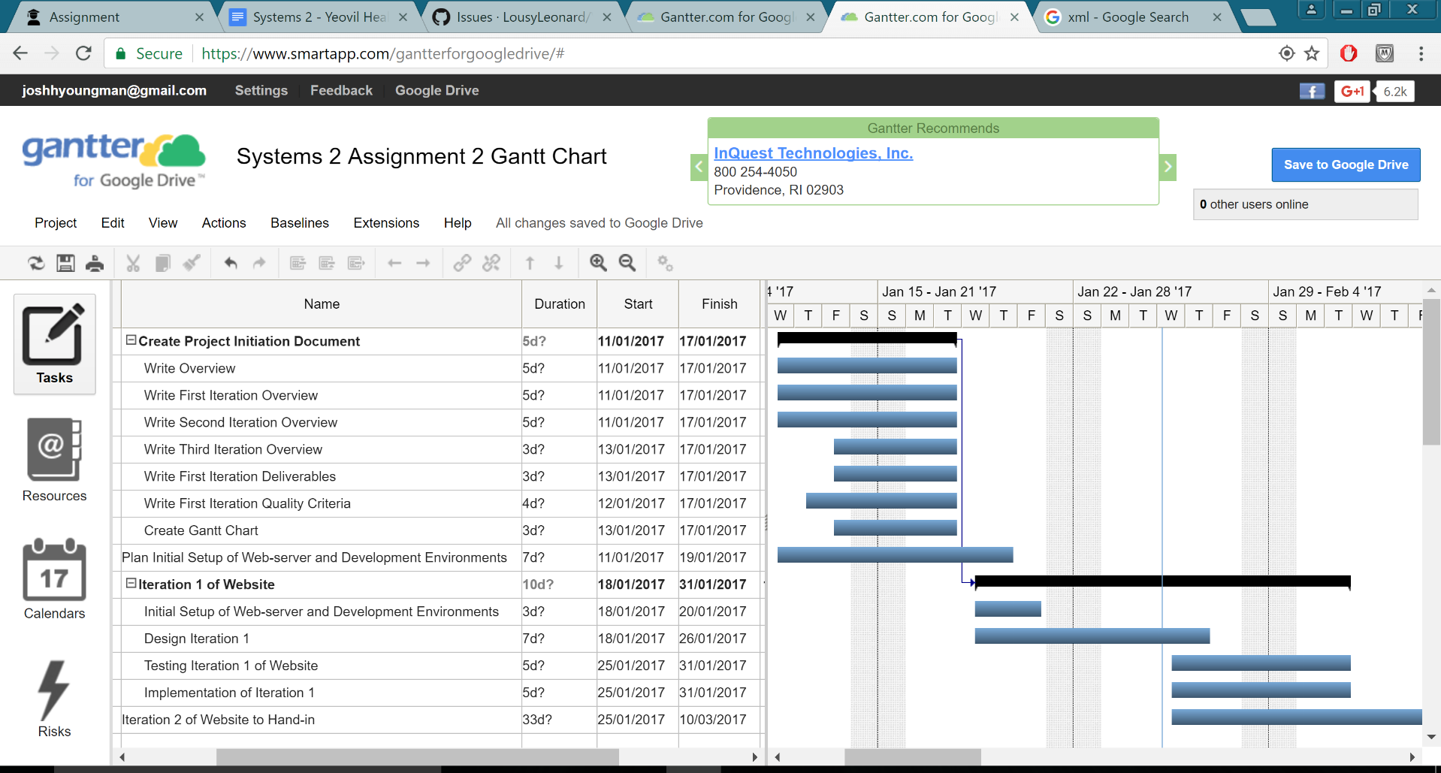The Gantt chart displays the different tasks that will be undertaken to complete the Initiation document, the first iteration of the website and when these tasks are to be completed. The Gantt chart shows the start and end date of each task giving a duration that each task will take. Once all the tasks are fully planned out, the overall start and end dates can be seen.

# Work Log

11/01/2017 - Lawrence Coles: Initial evaluation and decided on the contents of iterations 1 and 2.

11/01/2017 - Josh Youngman: Discussed iterations with Lawrence and decided on the contents of iterations 3 in the absence of Tommy.

11/01/2017 - Josh Youngman: Created document template and shared it with the team.

11/01/2017 - Lawrence Coles: Initial draft of overview, Initial draft of Iteration 1 in the Iteration overview.

11/01/2017 - Josh Youngman: Initial draft of Iteration 2 in the Iteration overview.

11/01/2017 - Lawrence Coles: Guidance memos for Deliverables, Quality Criteria, and Gantt chart.

13/01/2017 - Tommy Hamblin: Reworded and checked the grammar of previously completed work.

13/01/2017 - Tommy Hamblin: Discussed the requirements for iteration 3, as well as the project setup, with Josh and Lawrence.

13/01/2017 - Team discussion outcomes: The developmental server is to be built on Apache Tomcat along with Java server side scripting. This will be used in conjunction with the completion of the Internet Applications Development (IAD) assignment 2. Targets set to finish this initial document by 18/01/2017 for initial review. Development of Iteration 1 will commence on 18/01/2017.

13/01/2017 - Tommy Hamblin: Initial draft of Iteration 3 in the Iteration overview.

13/01/2017 - Lawrence Coles: Initial draft of the deliverables section. Second draft of Iteration 1.

14/01/2017 - Tommy Hamblin: Second draft of Iteration 3. Initial draft and second draft of the quality criteria section.

16/01/2017- Lawrence Coles: Updated version numbers. Removed hint text from Gantt chart section …

18/01/2017 - Lawrence Coles: Full read-through and review of document. Signed off.

18/01/2017 - Josh Youngman: Full read-through and review of document. Signed off.

18/01/2017 - Tommy Hamblin: Full read-through and review of document. Signed off.

25/01/2017 - Josh Youngman: Updates to document.

# Bibliography

Amazon, n.d. *Amazon.* [Online]. Available at: https://www.amazon.co.uk [Accessed 18 January 2017].

Hastings, T. (2008) *Quality of the Deliverables*. Available at: http://www.sqa.org.uk/e-learning/ProjMan03CD/page_06.htm [Accessed: 14 January 2017].

The Law Dictionary (n.d.) *What is QUALITY CRITERIA?* Available at: http://thelawdictionary.org/quality-criteria/ [Accessed: 14 January 2017].

Yeovil College, (2017). *Assignment Brief UCY*. Yeovil: Yeovil College, pp.1-6.

# Appendix

